**Id code:** 19CM029 **Name:** Dhiraj Jagtap **Sem:** 5th

**Practical No: 7**

**Aim:** Design a web page using following form controls:

a. Text box b. Radio button c. Check box d. Buttons

**Procedure:**

**Theory**

To show the values in the input fields after the user hits the submit button, we add a little PHP script inside the value attribute of the following input fields: name, email, and website. In the comment text area field, we put the script between the <textarea> and </textarea> tags. The little script outputs the value of the $name, $email, $website, and $comment variables. 

**Program:**

<html>

<head>

<title>Registration</title>

<style>

.main

{

 width:30%;

 margin:2em auto;

 border:2px solid black;

 padding:1em;

}

.main input[type="submit"]

{

 width:95%;

 border:1px solid black;

 padding:.5em;

 margin:.5em;

}

.main input[type="password"]

{

 width:95%;

 border:1px solid black;

 padding:.5em;

 margin:.5em;

}

.main input[type="text"],.main input[type="email"]

{

 width:45%;

 border:1px solid black;

 padding:.5em;

 margin:.5em;

}

</style>

</head>

<body>

<div class="main">

 <form method="post" action="welcome.php">

 <h2>Student Registration</h2>

  <input type="text" name="fname" placeholder="First Name">

  <input type="text" name="lname" placeholder="Last Name">

  <input type="email" name="email" placeholder="Email">

  <input type="text" name="mobile" placeholder="Mobile">

  <input type="text" name="city" placeholder="City"><br>

<hr>

  Gender<br>

  <input type="radio" name="gender" value="Male">Male<br>

  <input type="radio" name="gender" value="female">Female<br>

<hr>

  Hobbies<br>

  <input type="checkbox" name="hobby[]" value="Cricket">Cricket<br>

  <input type="checkbox" name="hobby[]" value="Football">Football<br>

  <input type="checkbox" name="hobby[ ]" value="Chess">Chess<br>

<hr>

  <input type="Password" name="pass" placeholder="Password"><br>

  <input type="submit" name="submit" value="Register">

 </form>

</div>

</body>

</html>

**Output:**

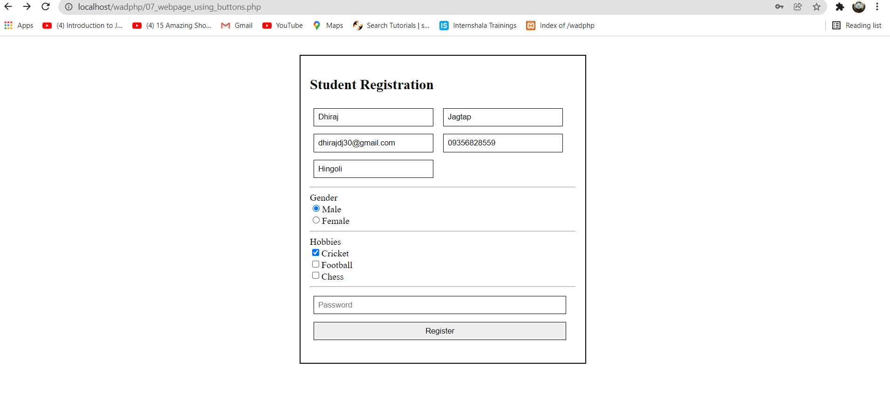

**Conclusion:** hence, we have seen the use of Text box, Radio button, Check box, Buttons.